- OBJECTIVES OF THIS COURSEWORK
- Develop the practical ability to describe, justify and implement an object oriented system.
- Introduce current technical issues in the field of object oriented programming (OOP).
- LEARNING OUTCOMES
At the end of this coursework, you should be able to:
- Create different basic coding solutions for small problems.
- Explain on the object oriented concepts and apply them using C#.
- Create an application by applying object oriented techniques.
- TYPE
- Group Assignment
- GROUP ASSIGNMENT DESCRIPTION
TPM Convenience store has decided to implement a Point of Sales System, which able to calculate the monthly Good and Service Tax (GST) payable to the Customs. According to the Royal Malaysian Customs General Guide, taxable consumer products can be divided into 2 categories; Standard-rated or zero-rated. Standard-rated products are subject to a positive tax rate of 6% whereas zero-rated products are subject to a tax rate of 0%. There are two types of users for the system; supervisor and cashier. Supervisor has the full access to the system, whereas the cashier only has the ability to access the checkout function.

Cashier
Cashier only has the ability to access the checkout function when concluding a sales transaction. He will enter all the items’ codes and quantity to calculate the total amount payable. A simple Tax invoice will be generated at the end of the transaction.

Supervisor
Supervisor has the same access as the cashier. Other than the cashier access, he has the ability to manage the product by determine it’s categories, price and reorder level threshold as well a generating report to monitor the sales performance and GST amount payable to the Customs.

Following is the basic requirements for the system. You can carry out an additional research to include any extra features into the system.
- A login and logout function to ensure authorise access.
- A product management function to determine the product details.
- A checkout function when conclude a sales transaction.
- Reporting function to show the sales performance and GST amount payable to the Customs.

Simple GST Tax Invoice generated at the end of sales transaction consists of the following details.
- The company name and details;
- Purchased items’ name, quantity, price and tax code;
- Total sales amount including GST, amount paid and change;
- GST summary
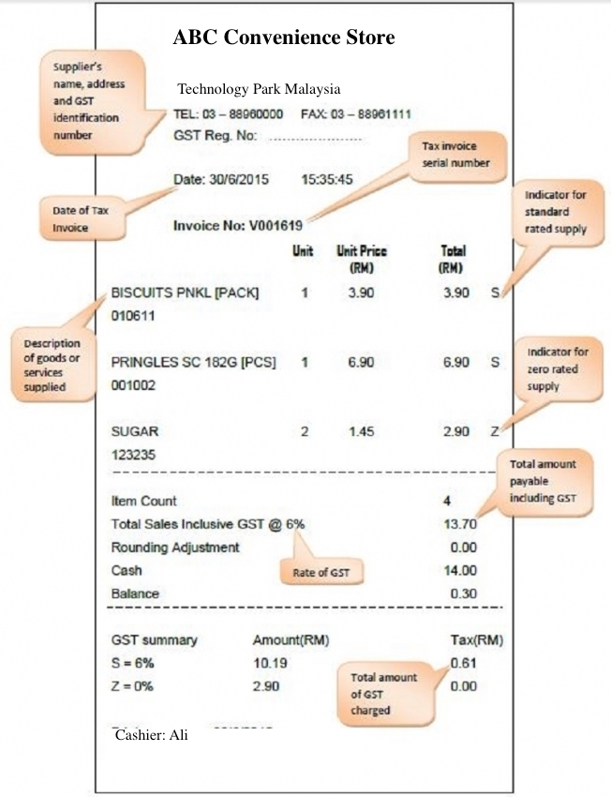
In this assignment you are expected to design, implement and test the following classes, which form the basis of the application:
- Cashier
- Supervisor
- Product
- Sales Transaction

IMPORTANT INSTRUCTIONS:

This is a group assignment. Each group should consist of between 2 – 3 members only. Upon submission of your assignment, you are required to present your assignment at a date and time specified by your module lecturer.

Each team member is required to contribute towards all sections of the assignment, present and explain his or her contribution of the work done. Each team member should also be able to answer questions posed with regards to the project and / or subject matter.

- GENERAL REQUIREMENTS
The program you submit should be able to compile without errors using Visual Studio. You should comply with the following coding style guidelines for the system:
- Use C# features
- Use GUI for the user interface
- Use object-oriented concepts in the solution
- Document your codes by using comments where necessary
- Use indentation
- Use meaningful names for identifiers
You should store all the data in a database management system such as Microsoft Access or Microsoft SQL Server Express Edition (this is bundled with Visual Studio), so that the information can be retrieved later. Alternatively you may also store the data using a database in Microsoft SQL Server or any database type.
You have to assume that this system is a stand-alone application and used by the specified users. Validation of input data should be implemented in the system to prevent errors. The implementation code must include at minimum the use of object oriented programming concepts such as classes, objects and inheritance.
DELIVERABLES:
6.1 WRITTEN ASSESSMENT DELIVERABLES
Submission of this will be made to the lecturer at the end of each lecture session.
6.2 GROUP ASSIGNMENT DELIVERABLES
- Point of Sales System with complete codes submitted in softcopy via CD or DVD.
- Documents delivered in printed and softcopy form.
Submission of deliverables should be made to the administrative counter on or before 7.00pm, dated 25 May 2017.

6.2.1 POINT OF SALES SYSTEM IN CD / DVD:
- The completed application must be compiled into an executable file (*.exe) and burned onto a CD / DVD
- The CD / DVD should also consist of either data or text files (e.g. *.dat or *.txt) and all relevant source code (*.cs).
- Do not compress your source code.
- The program must contain all the relevant source code.

6.2.2 DOCUMENTS: GROUP ASSIGNMENT REPORT
- As part of the assessment, you must submit the project report in printed and softcopy form, which should have the following format:

Cover Page:
All reports must be prepared with a front cover. A protective transparent plastic sheet can be placed in front of the report to protect the front cover. The front cover should be presented with the following details:
- Module
- Title : Point of Sales System
- Intake
- Student’s name and id
- Date Assigned (the date the report was handed out).
- Date Completed (the date the report is due to be handed in).

Contents:
- The design of the system using a Use Case diagram and descriptors for major Use Cases and a Class Diagram
- Description and justification of the implementation codes in terms of object oriented programming concepts – class & object, inheritance and polymorphism

Conclusion
- A critical evaluation of the work done and the lessons learnt in the process.

References
- You are advised to limit the number of pages of the report to TWENTY (20) pages. The font size used in the report must be 12pt and the font is Times New Roman. Full source code is not allowed to be included in the report. The report must be typed and clearly printed.
- You may source algorithms and information from the Internet or books. Proper referencing of the resources should be evident in the document.
- All references must be made using the Harvard Naming Convention as shown below:

The theory was first propounded in 1970 (Larsen, A.E. 1971), but since then has been refuted; M.K. Larsen (1983) is among those most energetic in their opposition……….

/**
* Following source code obtained from (Danang, S.N. 2002)
*/
int noshape=2;
noshape=GetShape();

- List of references at the end of your document or source code must be specified in the following format:

Larsen, A.E. 1971, A Guide to the Aquatic Science Literature, McGraw-Hill, London.

Larsen, M.K. 1983, British Medical Journal [Online], Available from http://libinfor.ume.maine.edu/acquatic.htm (Accessed 19 November 1995)
Danang, S.N., 2002, Finding Similar Images [Online], The Code Project, *Available from http://www.codeproject.com/bitmap/cbir.asp, [Accessed 14th *September 2006]

- Further information on other types of citation is available in Petrie, A., 2003, UWE Library Services Study Skills: How to reference [online], England, University of Western England, Available from http://www.uweac.uk/library/resources/general/info_study_skills/harvard2.htm, [Accessed 4th September 2003].

- GROUP ASSIGNMENT MARKING CRITERIA
Individual Component (30%)
- Presentation (10%)
- Q & A (10%)
- Contribution (10%)

Group Component (70%)
- Design (20%)
- CLASS Integration (25%)
- Documentation (25%)

- ACADEMIC INTEGRITY
- You are expected to maintain the utmost level of academic integrity during the duration of the course.
- Plagiarism is a serious offence and will be dealt with according to APU and Staffordshire University regulations on plagiarism.

CLASS DIAGRAM EXAMPLE
VENDING MACHINE SYSTEM

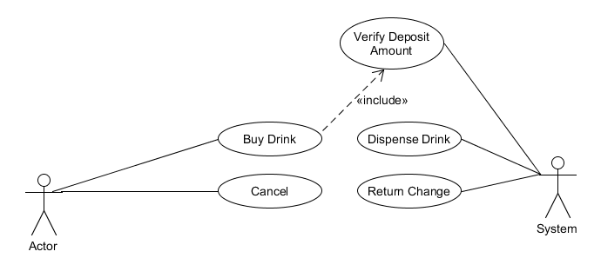

A SAMPLE USE-CASE DESCRIPTOR: VENDING MACHINE SYSTEM
(Note: This sample only for one use case)

USE CASE: BUY DRINK (VMS_01)

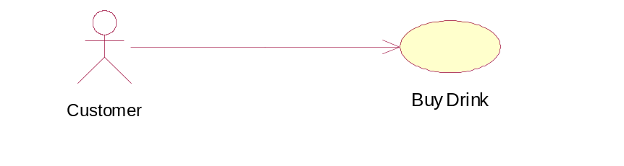

BRIEF DESCRIPTION
This use case is initiated by the customer. This use case will enable the customer to choose the drink, insert coins and obtain the desired drink.

PRE-CONDITIONS
The vending machine door is locked.

CHARACTERISTIC OF ACTIVATION
Event Driven (on customer’s demand)

FLOW OF EVENTS

Basic Flow (VMS_01_01)
- This use case begins when the customer presses the ‘Activate Customer Panel” button.
- The system shall display Customer Panel on the screen.
- The customer will select the drink and the system shall check to ensure the drink is available (E-1:Drink Not available). The system will display the drink is available at the Customer Panel.
- The customer shall cancel the transaction at any point during the transaction, the system shall dispense all the coins inserted and the system terminated. (E-2: Cancellation)
- The customer will insert the coins. The system shall validate the coin(E-3: Coin Not Valid), calculate the coin and display the accumulated coin.
- The customer shall insert the coin until the price is more than the accumulated coins and the system shall check the balance (E-4: Balance is not available)
- The system will update the coin denomination and display the balance to the customer.
- The system shall update and dispensed the drink.

Alternative Flow
Not Applicable.

Exceptional Flow
E-1: Drink not available.(VMS_01_02)
The system shall display the message “Drink is not available”. The system wait until the customer makes a new selection.

E-2: Cancellation. (VMS_01_03)
If the customer presses the cancellation button, the system shall display the message “Transaction Cancelled” and return all the coins inserted. This use case ends.

E-3: Coin not valid. (VMS_01_04)
The system shall display message “Coin not valid” and dispense the slug through the money tray. The system shall wait until the customer inserts valid coins.

E-4: Balance is not available. (VMS_01_05)
The system will display message “No Change Available” and return all the coins inserted.

POST-CONDITIONS
- The customer manages to buy drink
- The stock of drinks will be updated
- The coin denomination will be updated

RULE(S)
Not applicable.

CONSTRAINT(S)
The customer can only select one out of 5 types of drink for every transaction. Valid coin consists of 10 cents, 20 cents, 50 cents and RM1. Others will be identified as slug.

